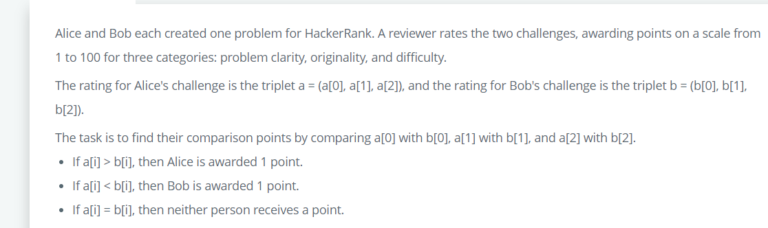

 count_alice=0

    c3=0

    l3=[]

**for** i **in** **range**(0,**len**(a)):

**if**(a[i]>b[i]):

            count_alice+=1

**elif**(b[i]>a[i]):

            count_bob+=1

**else**:

            c3+=1

    l3.append(count_alice)

    l3.append(count_bob)

**return** l3